**Deep Linking Android**

**What is Deep linking?**

Deep links are a concept that help users navigate between the web and applications. They are basically URLs which navigate users directly to the specific content in applications.

# What is Android App Links?

# On the other hand****,** Android App Links** allow an app to designate itself as the default handler of application domain or URL.**It works only on Android 6.0 (API level 23) and higher.**

**Work Flow Diagram:**

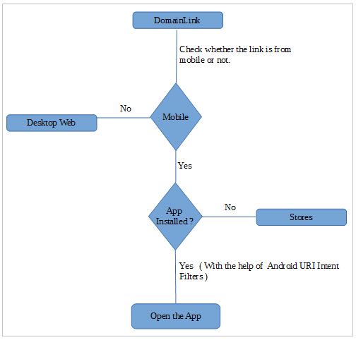

# A Scenario For Deep Links to App Content

When a user clicked URL, the Android system tries each of the following actions, in sequential order, until the request succeeds:

1. Open the user’s preferred app that can handle the URI, if one is designated.
2. Open the only available app that can handle the URI.
3. Allow the user to select an app from a dialog.

# How to define intent filters

When we talk about handling how to navigate users directly to specific content in **applications,**we should think about addingan intent filter in our manifest file. An intent filter should contain the following elements and attribute values.

1. Define **ACTION_VIEW** intent action so that the intent filter can be reached from Google Search.

<action android:name="**android.intent.action.VIEW**" />

1. We should include the **BROWSABLE** category in order to be accessible from a web browser. We should also have **DEFAULT** category for responding to implicit intents

<category android:name="android.intent.category.**DEFAULT**" />  
<category android:name="android.intent.category.**BROWSABLE**" />

1. We should define one or more <data> tags. Each of these tags represents a URI format that resolves to the activity. The following example represents **a simple data tag for zelle.com Android app.**

<**data**  
**android:host**="zelle.com"  
**android:scheme**="https" />

Android Manifest File:

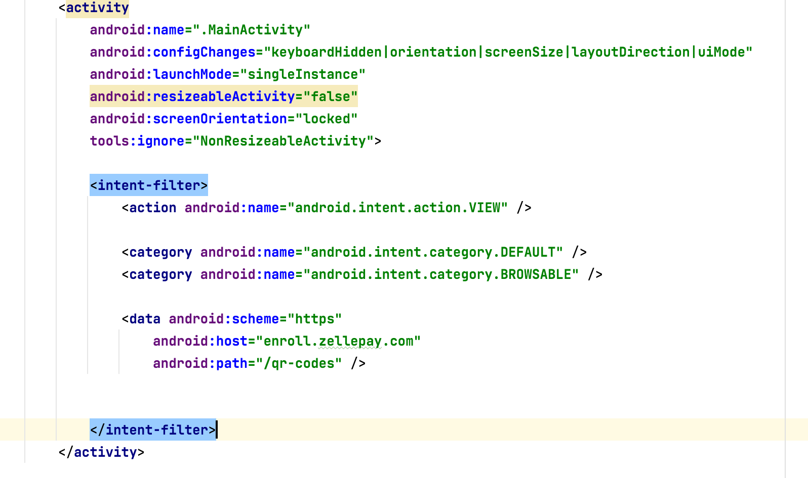

# How to read data from incoming intents

When you define your intent filter that can handle specific URLs, the system can start your activity via that intent filter.

Intent intent = getIntent();  
Uri data = intent.**getData**();

